Sravas Melarkode       Scan Me

WhiteHatJr Student

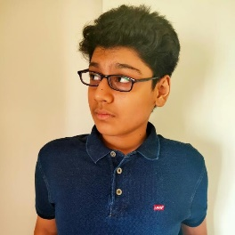 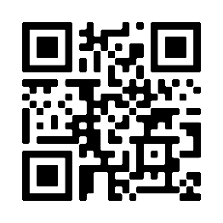

# ABOUT ME SKILLS

# Hey, I am Sravas Languages:- JavaScript, Java, HTML, JSX, React Native,

# Melarkode. I am a CSS, and Python

# 

# Coder in 8 languages, Coding Proficiency In:- Web Virtual Reality, Web

# a drummer, guitarist, Augmented Reality, Full Stack Engineering, and Game

# a singer, a YouTuber, Development.

# and a music record producer.

# HOBBIES

Doodling, Coding,

Working out

# PROJECTS

# Launch my app using the QR code on the top-right and scan the icons to know more about my projects.

# 

# BADGES EARNED

